**U18ISI6204 – Machine Learning Techniques**

**LAB EXPERIMENT- 7**

**NAME:** Navina G A

**ROLL_NO:** 20BIS028

Write a program to implement the naïve Bayesian classifier for a sample training data set stored as a .CSV file. Compute the accuracy of the classifier, considering few test data sets.

import pandas as pd

df=pd.read_csv("tennis.csv")

df

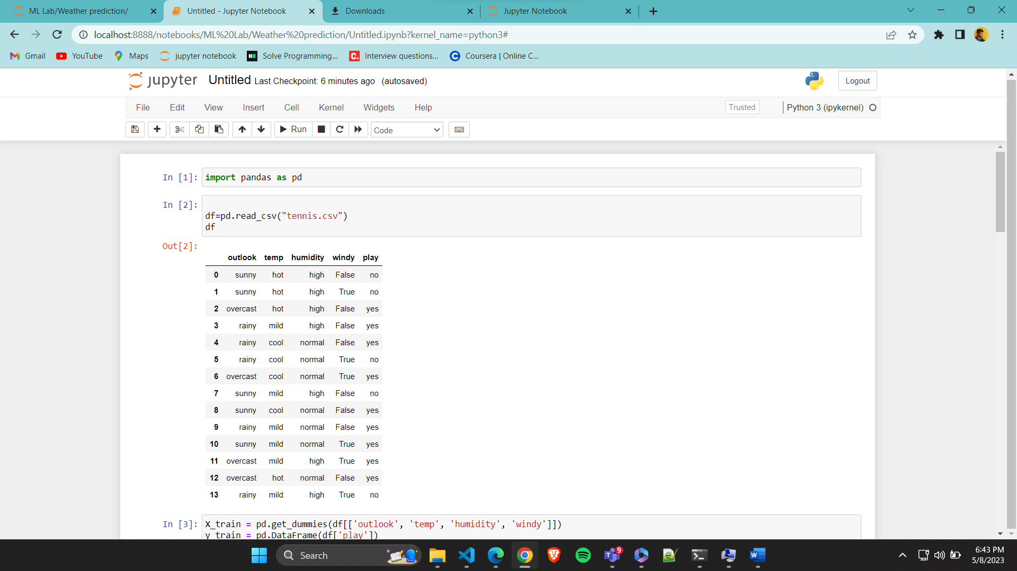

X_train = pd.get_dummies(df[['outlook', 'temp', 'humidity', 'windy']])

y_train = pd.DataFrame(df['play'])

print(X_train.info())

print(X_train.head())

print(y_train.info())

print(y_train)

from sklearn.naive_bayes import GaussianNB

classifier=GaussianNB()

classifier.fit(X_train,y_train)

classifier.score(X_train,y_train)

X_train.head()

classifier.predict([[True,0,0,1,0,1,0,1,0]])

y_train.head()

a=classifier.predict([[True,0,0,1,0,1,1,1,1]])

if(a[0]=="yes"):

print("yOU CAN PLAY!!!!")

else:

print("You cant play!!!")

